COMSATS UNIVERSITY ISLAMABAD,

ATTOCK CAMPUS


Submitted by:- M. Haider Iqbal
Submitted to:- Ms. Ambreen Gul
Registration #:- SP24-BSE-039
Date:- 12-Oct-2025
Assignment No:- 01

Question
Study Salsa20 Cipher and do the following activity.
1. Write python code for your designed stream cipher approach for encryption decryption, you can use approach from more than one already developed ciphers as given in lab practice exercises.
2. Design and implement an adversarial attack approach for your proposed stream cipher approach.
Instructions:-
- Prepare a clear report .doc file with code explanation and output screenshots.
Answer
from typing import Tuple
def arc4_crypt(data: bytes, key: bytes) -> bytes:
box = list(range(256))
j = 0
key_len = len(key)
for i in range(256):
j = (j + box[i] + key[i % key_len]) & 0xFF
box[i], box[j] = box[j], box[i]
i = 0
j = 0
out = bytearray()
for byte in data:
i = (i + 1) & 0xFF
j = (j + box[i]) & 0xFF
box[i], box[j] = box[j], box[i]
k = box[(box[i] + box[j]) & 0xFF]
out.append(byte ^ k)
return bytes(out)
def vernam_xor(data: bytes, key: bytes) -> bytes:
out = bytearray()
key_len = len(key)
for i, b in enumerate(data):
out.append(b ^ key[i % key_len])
return bytes(out)
def xor_bytes(a: bytes, b: bytes) -> bytes:
return bytes(x ^ y for x, y in zip(a, b))
def keystream_reuse_attack(cipher1: bytes, cipher2: bytes, known_plaintext1: bytes = None) -> dict:
result = {}
cxor = xor_bytes(cipher1, cipher2)
result['c1_xor_c2'] = cxor
if known_plaintext1:
L = min(len(known_plaintext1), len(cxor))
recovered = xor_bytes(cxor[:L], known_plaintext1[:L])
result['recovered_p2_prefix'] = recovered
else:
result['recovered_p2_prefix'] = None
return result
if __name__ == "__main__":
key_text = "SuperSecretKey!!"
key_bytes = key_text.encode('utf-8')
plaintext1 = "Dive Dive Dive".encode('utf-8')
ciphertext1 = arc4_crypt(plaintext1, key_bytes)
decrypted1 = arc4_crypt(ciphertext1, key_bytes)
print("ARC4 Example")
print("Plaintext1:", plaintext1.decode())
print("Ciphertext1 (hex):", ciphertext1.hex())
print("Decrypted1:", decrypted1.decode())
print("-" * 50)
key2_text = "thisismykey12345"
key2 = key2_text.encode('utf-8')
plaintext2 = "HELLO STUDENTS".encode('utf-8')
cipher2 = vernam_xor(plaintext2, key2)
plain2 = vernam_xor(cipher2, key2)
print("Vernam-style Example")
print("Plaintext2:", plaintext2.decode())
print("Cipher2 (hex):", cipher2.hex())
print("Decrypted2:", plain2.decode())
print("-" * 50)
pA = b"Hello Alice! This is secret A."
pB = b"Hello Bob! This is secret B, longer."
cA = arc4_crypt(pA, key_bytes)
cB = arc4_crypt(pB, key_bytes)
attack = keystream_reuse_attack(cA, cB, known_plaintext1=b"Hello Alice!")
print("Keystream reuse attack demo (ARC4 with same key used twice)")
print("cA ^ cB (hex):", attack['c1_xor_c2'].hex())
print("If attacker knows prefix of pA = 'Hello Alice!'")
print("Recovered prefix of pB:", attack['recovered_p2_prefix'].decode())
print("-" * 50)
v1 = vernam_xor(b"SECRET MESSAGE ONE", key2)
v2 = vernam_xor(b"OTHER MESSAGE TWO", key2)
attack_v = keystream_reuse_attack(v1, v2, known_plaintext1=b"SECRET ")
print("Vernam reuse attack demo (repeating-key XOR)")
print("v1 ^ v2 (hex):", attack_v['c1_xor_c2'].hex())
print("Recovered prefix of message2 (using known prefix of message1 'SECRET '):",
attack_v['recovered_p2_prefix'].decode())
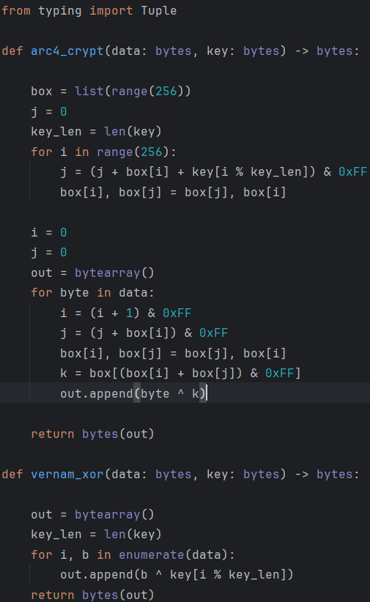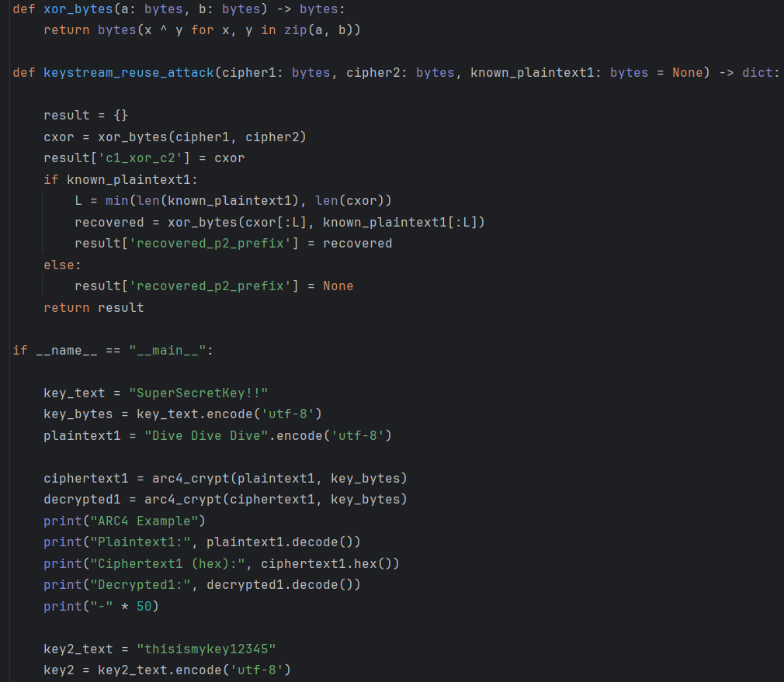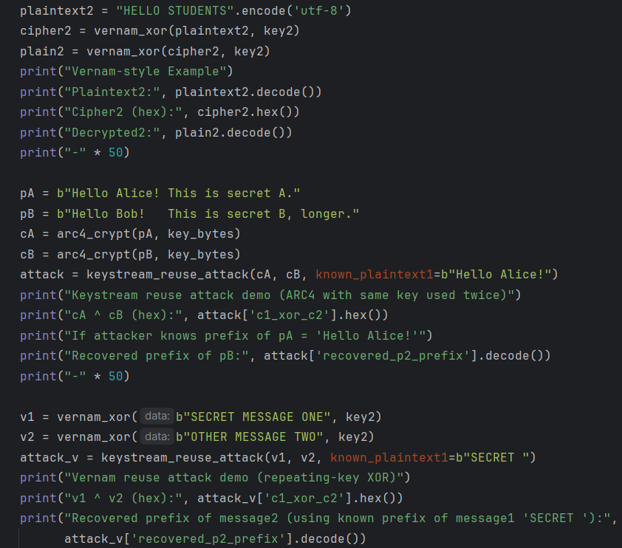

Output:
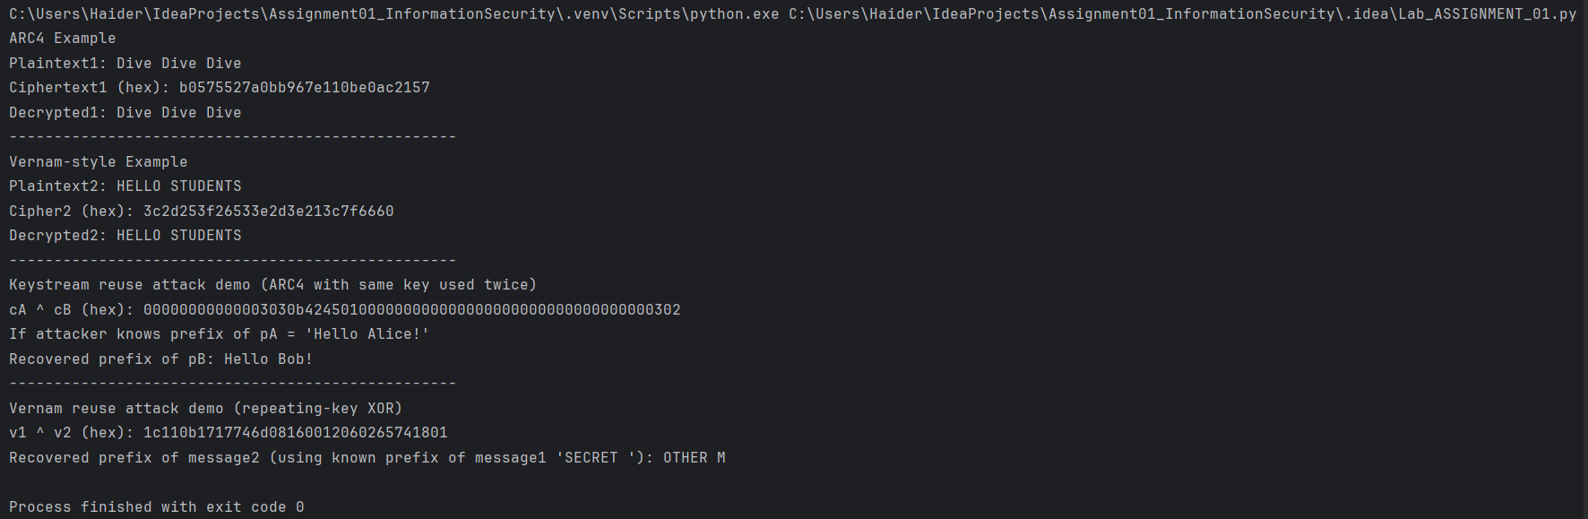
EXPLANATION

arc4_crypt (ARC4/RC4 function):
This function implements the RC4 stream cipher: it first builds a 256-byte state array and scrambles it with the key (Key-Scheduling Algorithm), then it repeatedly updates two indices and swaps positions in the state to produce a keystream byte (Pseudo-Random Generation Algorithm). Each input byte is XORed with a keystream byte to produce output, so the same function both encrypts and decrypts because XOR is reversible.
vernam_xor (Vernam / repeating-key XOR):
This function applies a simple repeating-key XOR: it walks through the data and XORs each byte with a byte from the key, repeating the key if the data is longer; running the same function again with the same key reverses the operation and returns the original text.
xor_bytes (helper):
This small helper takes two byte strings, pairs their bytes, XORs each pair, and returns the result; it is used to compute values like c1 ^ c2 which reveal relationships between plaintexts when the same keystream has been reused.
keystream_reuse_attack (attack demo):
This routine demonstrates the core weakness of reusing a keystream: it computes c1 ^ c2 (which equals p1 ^ p2 if the keystream is the same), and if an attacker knows some bytes of p1 they can XOR those with c1 ^ c2 to recover the same bytes of p2; this shows why reusing keys/nonces is dangerous.

ARC4 example in main:
The demo creates a key and plaintext, encrypts using arc4_crypt, then decrypts by calling the same function again to show encryption is reversible; printed hex values let you verify that encryption changed the data and decryption restored it.
Vernam example in main:
The demo shows repeating-key XOR by encrypting a short message and decrypting it with the same function, illustrating again that XOR is symmetric and that a repeating key is easy to experiment with but insecure if reused across messages.
ARC4 keystream-reuse attack demo in main:
This example intentionally encrypts two different messages with the same ARC4 key to produce the same keystream; the code then computes cA ^ cB and, using a known prefix of the first message, recovers the corresponding prefix of the second message — demonstrating the two-time-pad vulnerability.
Vernam reuse attack demo in main:
This shows the same idea for repeating-key XOR: two messages encrypted with the same short key leak information via v1 ^ v2, and a known substring of one message can be used to reveal the corresponding substring of the other.

- The code shows two simple stream-cipher methods (ARC4 and repeating-key XOR), demonstrates encryption and decryption (XOR is reversible), and proves that reusing the same keystream/key for different messages lets an attacker recover secret data by XORing the two ciphertexts.

